student name: Xie Zhou

student id: 912143385

PS0

Part1. Using Matlab

1. Get familiar with Matlab

2.

a. >> x = randperm(500);

Assign to “x” a row vector (1x500), containing a random permutation of numbers from 1 to 500.

b. >> a = [1,2,3; 4 5 6; 7 8 9];

>> b = a(3,:);

Assign to “a” a 3x3 matrix; semicolons mark the end of a row.

Assign the third row of “a” to “b; b is a row vector : [7 8 9].

c. >> a = [1,2,3; 4 5 6; 7 8 9];

>> b = a(:);

Assign to “a” a 3x3 matrix; semicolons mark the end of a row.

Assign to “b” all values in “a” row by row; “b” is a column vector. (9x1).

d. >> f = randn(10,1);

>> g = f(find(f > 0));

Assign to “f” a column vector (10x1), containing 10 normally distributed random numbers.v

Find the numbers in “f” whose values are greater than “0”, and assign the column vector of the numbers to “g”.

e. >> x = zeros(1,5)+0.5;

>> y = 0.5.\*ones(1,length(x));

>> z = x + y;

Assign to “x” a row vector of size 5, consisting all “0”s; make them all “0.5”s by addition.

Assign to “y” a row vector, consisting all “0.5”; its size is the number of columns in x.

Assign to “z” the sum of vectors “x” and “y”.

f. >> a = [1:50];

>> b = a([end:-1:1]);

Assign to “a” a row vector, consisting 50 ordered numbers from 1 to 50.

Reverse “a” and assign the resulting vector to b.

3.

a. round(1+5\*rand(1))

b. Z = reshape(y,[2,3])

c. x = max(max(Z));

[r,c] = find(Z == x);

d. x = length(find(v == 8));

4.

4a. 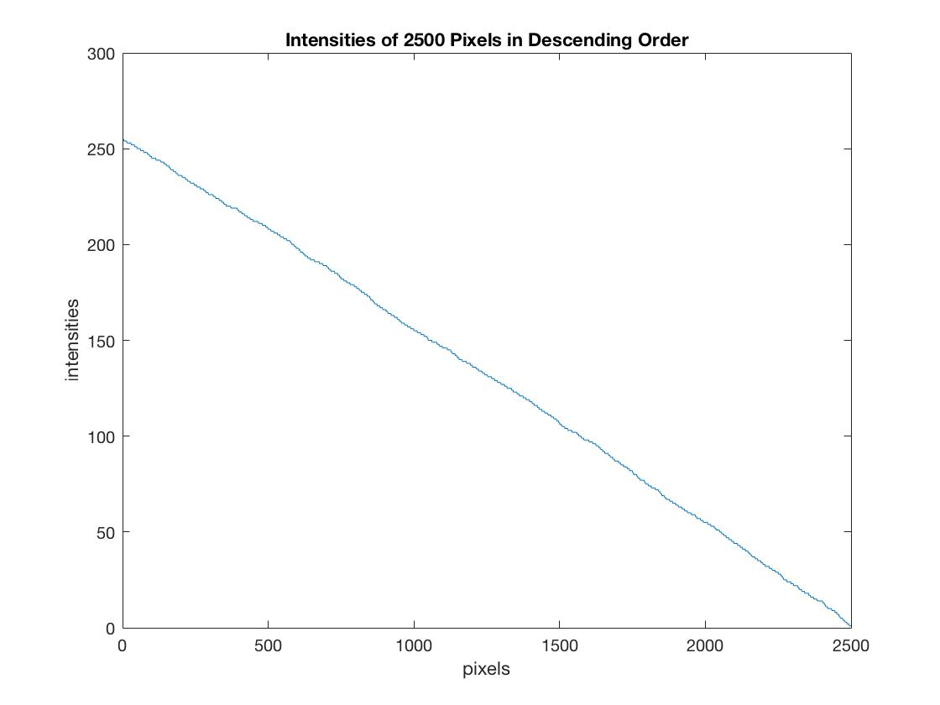

4b. 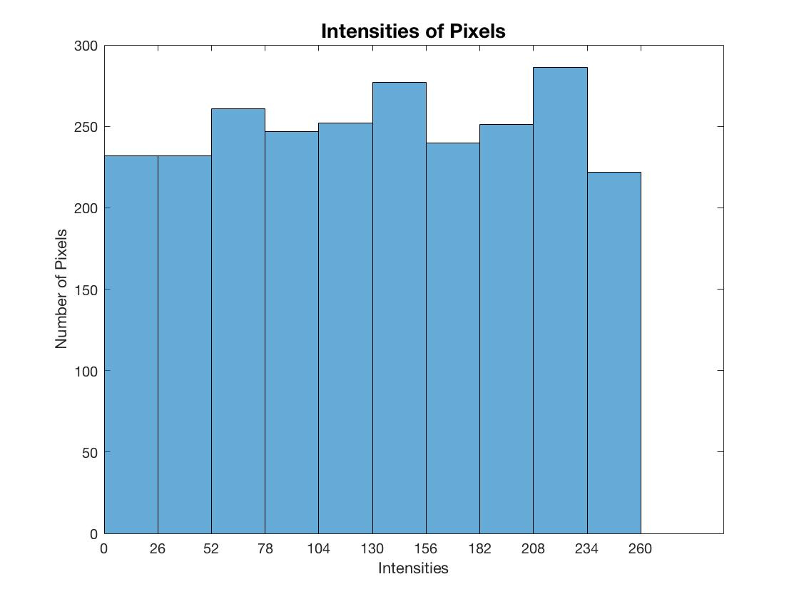

4c. 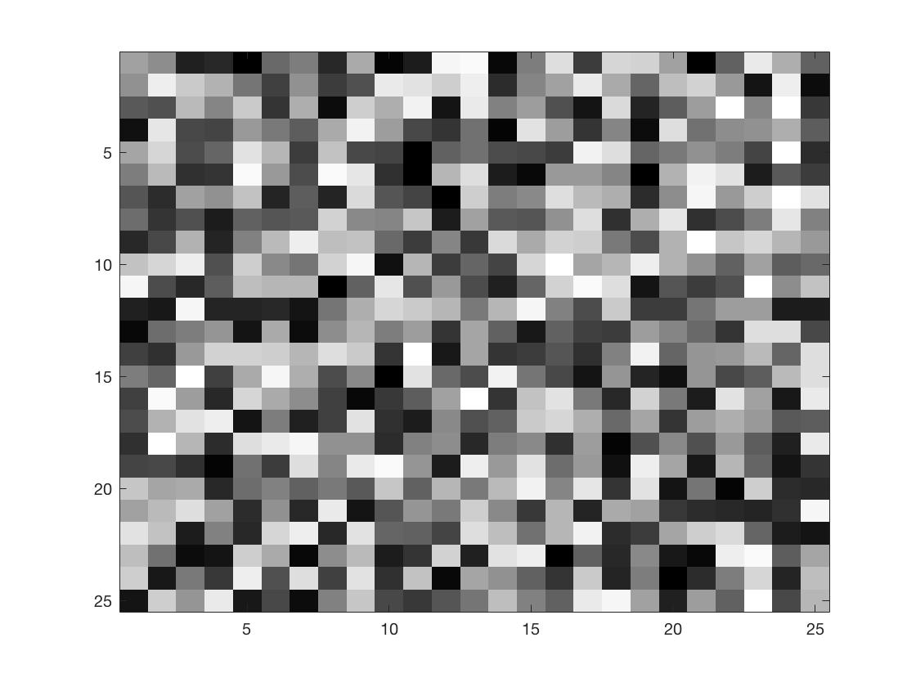

4d. 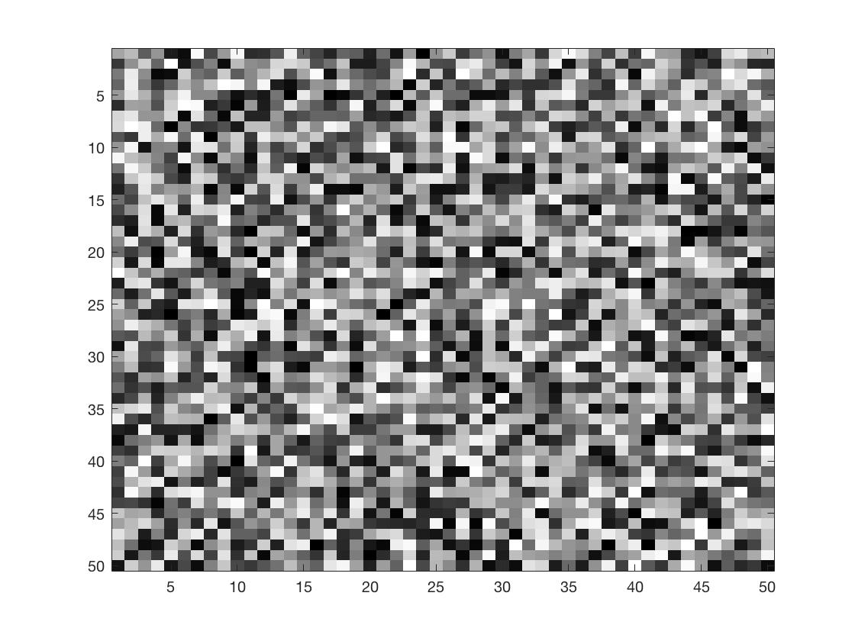

4e. 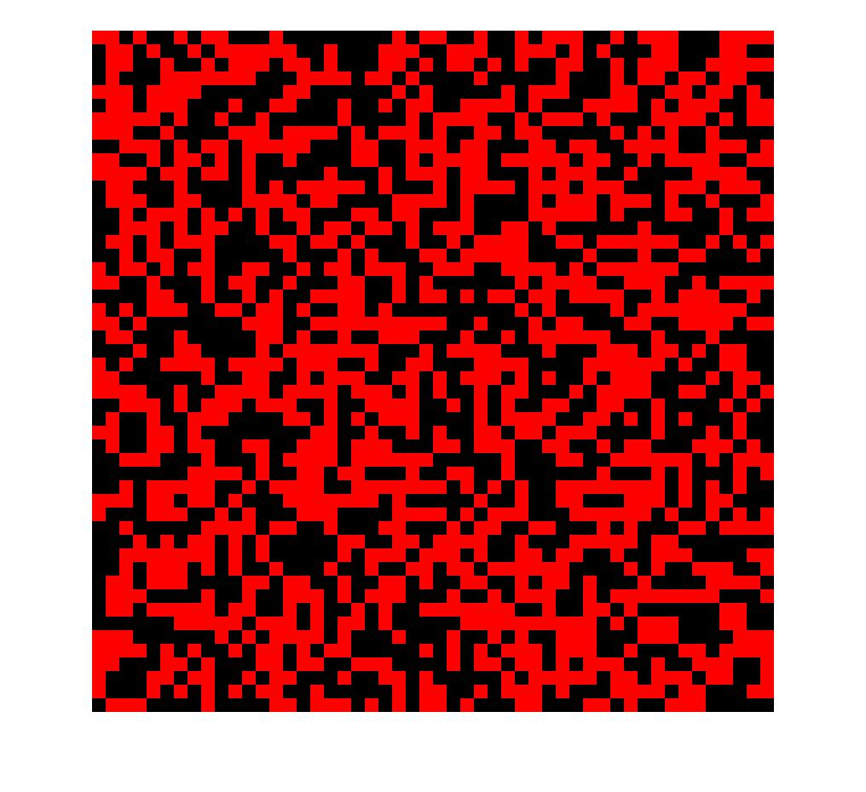

Part2. Short Programming Example

(*Note: used addition, randnum = 128, for “f”,)*

